Policies_Verifying Agency Billed Policy_Instance43_29-May-2018_03-37-37_AM_ValidationofAgencyBilledPolicy.png

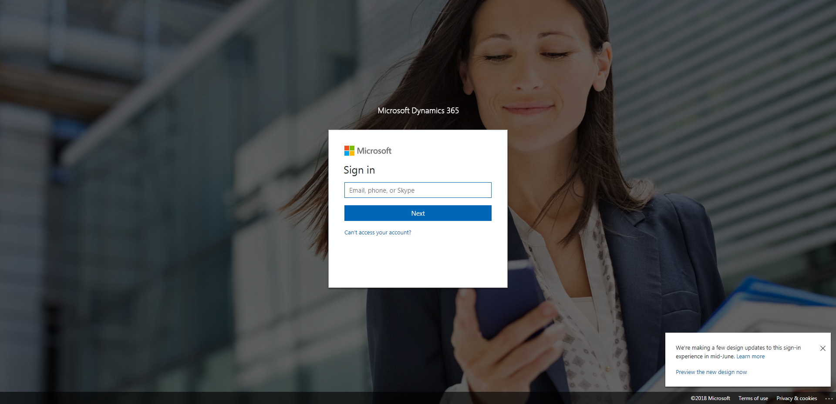

Policies_Verifying Agency Billed Policy_Instance43_29-May-2018_03-37-35_AM_SingleSignOn.png

